Application  ISO 9001 |   Customer Credit
- Scope of application
This procedure applies to all ArcelorMittal Construction France customer orders, outside the group, managed in the IT system.

- Expected results
The purpose of this procedure is to check the customer's solvency and manage customer risk in the context of invoice payment.

- Customer credit
  - Customer account opening
    - Flow chart :
Process / Area | Procedure
CL | 03

 | EDITOR | APPROVER
Name : | Camille FEIGRE | Mélanie LAIOLO
Position : | Quality Project Manager | Controlling Manager

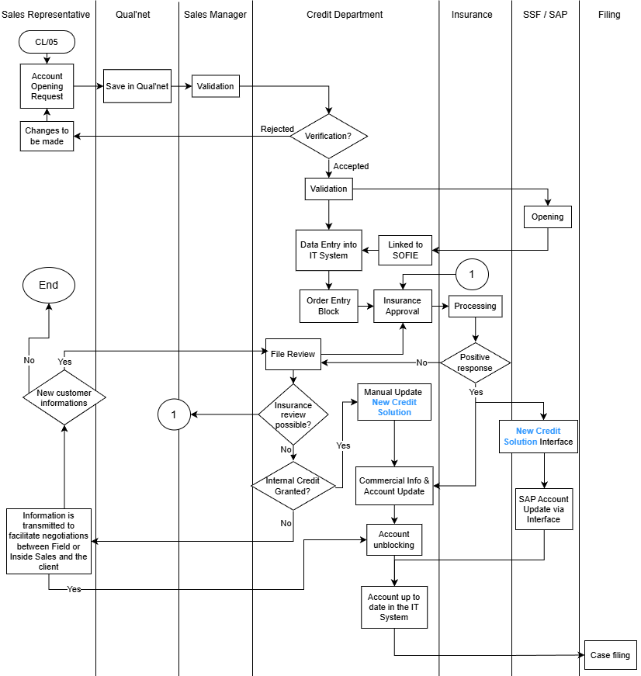

- Description Insurance approval:
A request is made to AMCF's Credit Insurance, which consists in granting a credit for a customer. This request is sent by e-mail or Internet to Insurance.
The latter responds by e-mail or Internet within a short timeframe, and sends an endorsement to the customer credit department for confirmation.

File review / AMCF credit approval
The Credit Manager examines the file for the granting of a credit to a customer.
Customer credit is granted:

In addition to insurance or  Without credit insurance | Up to €100k | Validation by the AMCF credit committee
In addition to insurance or  Without credit insurance | Over €100k | Validation by AMCF Credit Committee and AMDS Management and/or Chief Financial Officer • Distribution Solutions
All internal credits are approved by the AMCF Credit Committee.
The decision is confirmed to the itinerant or sedentary by e-mail or via the SOFIE software.

Manufacturing block :
  - Logigram
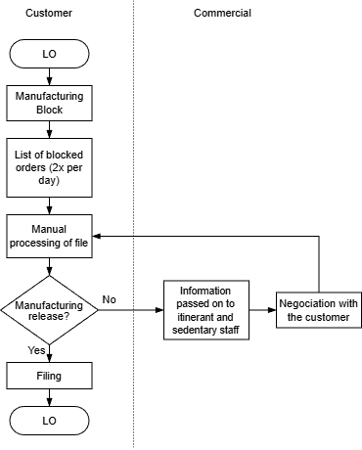

  - Description
Manual file processing :
Manual handling of the file includes operations to verify the status of a customer's account (review of credit granted to a customer, investigation, balance sheet, etc.). If necessary and possible, a new request for review can be made to the credit insurer.
Blocking :
An order is automatically blocked by the IS for various reasons:
    - Late payment (from day 1)
    - Credit overrun (authorized by insurance and customer credit)
    - Customer under surveillance

Shipping block:
  - Logigram
Customer credit
Sales and/or Accounts receivable
LO
Customer under surveillance or late payment?
Yes
Blocked shipments
No
List of orders blocked for shipment
Payment up to date + compliance with payment terms
No
Yes
No
Solution?

Yes
LO

LO
Order on hold - blocked
Contact customer
List of orders blocked for shipment
Order release
  - Description Late payment :
Interventions are carried out by telephone reminders from the customer credit/collection or sales department. Paper reminders are also issued by the SAP system (1st reminder and 2nd reminder).
Non-compliance with commitments :
Interventions are carried out by the sales department or the customer credit department, when commitments made during negotiations on order settlement conditions are not honored.

Filing/archiving:
Customer file :
All information concerning recordings (duration, place of filing and archiving, etc.) are listed in Form GD/00/00/02 updated by the QSE department

Billing / Collection :

Invoicing :
Invoice creation is triggered by the creation of the dispatch note. Invoices are issued and posted the night following creation of the dispatch note.

Collection:
Collection is carried out using an internal customer reminder software package. An initial paper reminder is sent to each customer 5 days after the due date, followed by a second reminder within 15 days. Collection action may take the form of a telephone reminder, a request for action to the sales department, or a formal notice. In some cases, this action may lead to the submission of the file to the credit insurance company.

Reporting

Group reporting (to AM Corporate) is carried out monthly after each closing of accounts. This report highlights credit overruns (company risk > 10 K€) as well as overdues (due dates exceeded > 100 K€).

References :

CL/05: Check and record orders
LO: Track orders internally
CL/02/03: ORDER TRACKING AND DELIVERY INSTRUCTIONS
CL/05/01: Order tracking and delivery (outside France)

